## *Install CriticalSpacing & NoiseDiscrimination

Denis Pelli, June 26, 2019

[denis.pelli@nyu.edu](mailto:denis.pelli@nyu.edu?subject=installing%252520CriticalSpacing)

**CriticalSpacing.m** is a MATLAB program developed by Denis Pelli at NYU, with help from Hörmet Yiltiz. You can read more about this program and its purpose in our 2016 article:

Pelli, D. G., Waugh, S. J., Martelli, M., Crutch, S. J., Primativo, S., Yong, K. X., Rhodes, M., Yee, K., Wu, X., Famira, H. F., & Yiltiz, H. (2016). **A clinical test for visual crowding.** *F1000Research* 5:81 (doi: 10.12688/f1000research.7835.1) <http://f1000research.com/articles/5-81/v1>

To run CriticalSpacing on your machine (running MacOS, Windows, or Linux), you need software (MATLAB, Psychtoolbox, and CriticalSpacing) and a few tools (a measuring tape, perhaps a wireless keyboard, and possibly a mirror). Please follow the steps below:

**NoiseDiscrimination.m** is a MATLAB program developed by Denis Pelli at NYU. It measures threshold contrast for identification in static or dynamic noise. Pelli & Farell (1999) explain why it’s useful and interesting to measure thresholds in noise.

Pelli, D. G. & Farell, B. (1999) **Why use noise?***Journal of the Optical Society of America*A, 16, 647-653. <http://psych.nyu.edu/pelli/pubs/pelli1999noise.pdf>

The signal can be known exactly (one of several letters or gratings) or statistical (white noise with one of several known envelopes). To run NoiseDiscrimination on your machine (running macOS, Windows, or Linux), you need software (MATLAB, Psychtoolbox, and NoiseDiscrimination) and a few tools (a meter stick or measuring tape and a photometer). Please follow the steps below:

### A. Install MATLAB (Already have it? Skip to step 14.)

1. *If you’re a member of NYU working remotely.* Note that “localweb.cns.nyu.edu” links (used for installation) and the NYU MATLAB license server (used to run MATLAB) only work locally. You must be on the NYU network, connected either directly, or, if you’re off campus and you have an NYU net id, through a VPN connection to campus via the internet, using a free program called “**Cisco AnyConnect**” that you can get from NYU here:  
   <http://www.nyu.edu/life/resources-and-services/information-technology/getting-started/network-and-connectivity/vpn.html>
2. *If you’re on the NYU Campus or a member of NYU.* Here are general instructions, with sections for macOS, Windows, and Linux: <https://localweb.cns.nyu.edu/installmatlab/>

(For convenience we copied the macOS and Windows instructions below.)

**macOS**: To install MATLAB in one easy step, copy these two lines into the Terminal app:  
 caffeinate -i sudo /bin/bash  
 curl localweb.cns.nyu.edu/mac/matlab.tgz | tar xz -C /Applications

(The first line grants admin privileges and prevents sleep. The second copies the latest version of MATLAB as a compressed tarball, removes it from quarantine, and unpacks it into your /Applications directory.) This avoids the quarantine-tag obstacle that you must overcome if you download manually.  Then skip to step 9. (Thanks to Paul Fan.)

**Windows**: Click here to download the matlab.iso image file for the current MATLAB:  
<http://localweb.cns.nyu.edu/windows/matlab.iso>  
Double click the iso image in the Explorer to mount it. For concreteness let us assume it is mounted at drive Q (the drive letter will vary). Then from drive Q, copy the two files license.lic and installer_input-win.txt into the folder C:\TEMP (create it if not there). Click the Start menu and select the Run option. In the Run dialog box, enter

Q:\setup.exe -inputFile C:\TEMP\installer_input-win.txt

[Replace Q with whatever letter your system mounts the iso image at.]

1. *Member of Pelli lab?* Borrow our thumb drive to copy the MATLAB installer onto your computer. If you need to do it from home, contact Denis for special instructions.
2. *Rest of world?* Unless your university has a site license (as NYU does), you’ll need to buy MATLAB. The [**student version**](https://www.mathworks.com/academia/student_version.html) is fine, and costs **$99**/year for the suite, or just $49/year for the basic MATLAB app plus $10/year for the Image Processing Toolbox. (The Image Processing Toolbox, includes the rgb2lin function that is used when you ask NoiseDiscrimination to convert RGB images to grayscale. Otherwise, I think the basic MATLAB version suffices, but we haven’t checked this.)
3. **Windows**: You must mount the “iso” file (a disk image). In Windows 8 and above, you just double-click the archive. And here’s [**help**](https://www.lifewire.com/how-to-change-a-drive-letter-2626069) on how to change the mounted iso drive’s assigned drive letter name.
4. **macOS:** *Remove tarball from quarantine before unwrapping it.* Unless you used the method of step 2, above, you should explicitly remove your tarbell from quarantine. If you download the MATLAB tarball via your browser, please run the following commands in Terminal before unwrapping the tarball:  
    cd ~/Downloads  
    xattr -d com.apple.quarantine MATLAB.app.tgz  
   (or whichever MATLAB tarball you downloaded). If you download the MATLAB tarball via your browser, macOS will tag all the files within your MATLAB.app with a com.apple.quarantine attribute. It will then take MATLAB forever to launch. If you already unwrapped the tarball, then do  
    xattr -dr com.apple.quarantine MATLAB.app  
   For more on quarantine and xattr, see Paul’s[note](http://www.cns.nyu.edu/unixadmin/#february22-2016)
5. *Install* *MATLAB*. Double-click to unpack the archive and reveal the installer. Double click the installer file, and install with the default options. You should end up with a MATLAB app with the familiar rust-colored icon.
6. **macOS:** *Another way to overcome quarantine.* Steps 2 and 6, above, suggest two ways to remove your MATLAB from quarantine. If you don’t do either, you could instead give your computer special permission to open MATLAB despite the quarantine. Before you try to open MATLAB for the first time, go to the System Preferences: Security and Privacy: General tab. Click the lock (lower left corner) to open it, providing your password. Set “Allow apps downloaded from anywhere.” Click the lock again to close it. If you try to open MATLAB without that permission, you’ll get a mysterious message from the Finder, saying it’s “Verifying”, which never goes away. Once MATLAB has been opened once, you should restore the old restriction in System Preferences: Security and Privacy.
7. *NYU-license for MATLAB.* Have an NYU net id? Connect to NYU. NYU has a site license for MATLAB. Your installation of MATLAB has a license file inside your MATLAB that checks the NYU license server every time you use MATLAB. That works when you’re connected to the NYU network, either directly (in an NYU building) or indirectly by a “virtual private network” (VPN), as explained in Step 1 above.
8. *Configuring the NYU-license for MATLAB, off campus****:***The NYU Dept. of Psychology and Center for Neural Science are in the Meyer Building. The versions above contain the license files that we use on the Meyer network. They are in a subfolder of the MATLAB app named licenses and are configured for the Meyer network (wired / wireless). However, if this MATLAB will be used off the Meyer network, then it is highly recommended you use just the **3network.lic** license file. MATLAB takes many minutes to time out with each file, and thus may waste 10 to 15 minutes attempting to connect with other license files before eventually succeeding with 3network.lic. So, go to the licenses folder and move all files there, apart from 3network.lic, to a subfolder for safe keeping and rename 3network.lic to network.lic. (Thanks to Paul Fan.)
9. *Pelli-lab standalone license for MATLAB.* If you are working in the Pelli Lab, you may be eligible for a stand-alone license that works without an internet connection to NYU. In that case you should send Denis an email with key information identifying your computer. We need your computer’s MAC Address (Media Access Control). Note that “MAC” has nothing to do with “Macintosh”. Here’s how to discover your computer’s MAC number:

* If you are in macOS, use Spotlight to search for Terminal, then, in the Terminal application, type   
   ifconfig  
  and press Enter. Copy all the output to send to Denis, below.
* If you are in Windows, press Win+R and enter cmd in the dialog box. Press enter to open the cmd application. In cmd (a black window), insert ipconfig then press enter. Copy all the output to send to Denis, below.
* Email [denis.pelli@nyu.edu](mailto:denis.pelli@nyu.edu), specifying your full name, the *specific kind of computer* you have, and the text you copied above that includes your computer’s MAC number.
* If eligible, you will be provided with a stand-alone MATLAB license and instructions on how to install it into your MATLAB. (In **macOS**, the license file must be placed in the folder /Applications/MATLAB.app/licenses/. To get there, you must Control-click to open the MATLAB application package, in which you’ll find the licenses/ folder. The procedure is similar in **Windows**.)

1. *Rest of world?* You’ll need a license from Mathworks to run MATLAB. See step 4 above.
2. *License trouble?* If you’re using an NYU license (on or off campus) please contact [denis.pelli@nyu.edu](mailto:denis.pelli@nyu.edu?subject=installing%252520CriticalSpacing). Contact Mathworks only if you bought your license from them.
3. **macOS:** *Tell your Mac to open *.m files in MATLAB.* By default, when you double-click a file whose name has the extension .m (i.e. any MATLAB program), macOS opens the file in its development system called XCode. If you’re reading this document, that is almost certainly not what you want. I suggest that you change the default:

* Select any file with the .m extension. Hit Command-I. The Finder will open a window with information about your file. About halfway down is “Open with:”. Use the pop-up menu to select MATLAB. And, *very important*, hit “Change All”. From now on, all .m files will open in MATLAB.

### B. Install Psychtoolbox (Already have it? Skip to step 4.)

We use Psychtoolbox in our MATLAB programs to control the display. Every issue labeled with a green check **✅** is assessed by running **InstallationCheck.m**.

1. Follow this link to **install Psychtoolbox**:  
   <http://psychtoolbox.org/download/>  
   Carefully follow the instructions at the Psychtoolbox website. It is not entirely automatic. It needs your help to finish the installation. For example, you typically need to install additional software, including svn and Gstreamer, depending on your Operating System. Under macOS you’ll need to complete the following steps 2 and 3 to succeed in running DownloadPsychtoolbox.
2. **macOS**: **Install Apple’s XCode to get new svn.** To download or update the Psychtoolbox, you need svn. It’s included in Apple's free XCode developer software, so if you don’t have svn, then DownloadPsychtoolbox and UpdatePsychtoolbox will fail. To get svn, you should go to the macOS App Store and download XCode for free. When you run the XCode app, and give it permission, it installs a fresh copy of svn.
3. **macOS**: **Delete obsolete svn.** DownloadPsychtoolbox or UpdatePsychtoolbox mail fail with a mysterious error message from svn, saying it was rejected by GitHub.SinceFebruary 2018, GitHub no longer accepts the (obsolete) version of svn at /opt/subversion/bin/svn. Delete it by using the Terminal command

rm -R /opt/subversion/bin/svn  
The Psychtoolbox function GetSubversionPath tells you which svn you’re using. The Terminal command  
which -a svn  
shows you all the versions of svn in your path. (Thanks to Mario Kleiner and [microfish@fishmonkey.com.au](mailto:microfish@fishmonkey.com.au).)

1. If MATLAB is write-protected (e.g. because it’s in the Applications directory) then you should **enable write permission for two MATLAB files, pathdef and javaclasspath.txt**. That will allow UpdatePsychtoolbox to customize them to help MATLAB find the m and java files in Psychtoolbox. The following instructions are for **macOS**; I think the procedure for other OSes will be similar. For pathdef, the MATLAB command   
   which pathdef  
   will give you its Finder path. For javaclasspath, the general case is complicated (and explained in “help PsychJavaTrouble”), but its Finder path will be given either by the MATLAB statement,which javaclasspath.txtor, if that fails, then this,  
   [prefdir(1) filesep 'javaclasspath.txt']In each case, paste the Finder path into Finder/Go/Go to Folder/, then select the file, hit Command-I (Get Info), and grant write permission. Once both files have write permission, then run UpdatePsychtoolbox to customize them to include Psychtoolbox files.
2. **✅** **Update Psychtoolbox**. If you already have Psychtoolbox, from more than a month ago, please update to the latest version by typing in the MATLAB Command Window:  
   UpdatePsychtoolbox  
   macOS: Note that you’ll need to have completed prior steps 2, 3, and 4 to succeed here.
3. **✅** Try running **GratingDemo** —just type it in MATLAB’s Command Window—to confirm that Psychtoolbox is installed and can control your display.
4. **✅** Run this to **confirm that sound works**:

Snd('Play',MakeBeep(256,1));

It should beep for one second. If you encounter problems, get advice by running:  
 help PsychPortAudio  
in the MATLAB Command Window.

1. **✅** Type **Speak**('hello') to confirm that speech synthesis works.
2. **✅** **macOS**: **DrawText:** In order for Psychtoolbox to be able to load the current DrawText plugin you must install the X11 Quartz window package:   
   <https://support.apple.com/en-us/HT201341>  
   In case of trouble, type “help DrawTextPlugin” in the MATLAB Command Window.
3. **✅** **macOS**: **DrawText:** *Delete obsolete version of libfreetype.6.dylib in MATLAB* (most versions up to and including 2018a). In order for Psychtoolbox to be able to load the current DrawText plugin from X11 Quartz, you must delete or rename this obsolete (version 18) library in MATLAB (most versions up to and including 2018a). Type this into Terminal:  
    rm /Applications/MATLAB/bin/maci64/libfreetype.6.dylib  
   In case of trouble, type “help DrawTextPlugin” in the MATLAB Command Window. If you have trouble, Mario Kleiner suggests using the Terminal app to find all instances of this file on your disk:

find / -name 'libfreetype.6.dylib' 2>/dev/null

(the last term redirects all errors, like “Permission denied” warnings, to a null device), and then checking the version number of each one, e.g.

otool -L /opt/X11/lib/libfreetype.6.dylib

As of this writing (June 2019), you want compatibility with version 19. Having an extra obsolete library (e.g. compatibility version 18) can cause trouble, because it may be found and used in place of the current library. Remove or rename any obsolete copy. In my experience installing on dozens of Macs it was always enough to just delete the one inside MATLAB, as explained above.

1. **✅** **Microsoft Windows with MATLAB: DrawText:** You will need to install the **GStreamer** multi-media framework – see MATLAB "help GStreamer" for installation instructions. Otherwise Psychtoolbox will use the old lower-quality GDI text renderer instead. In case of trouble, see “help DrawTextPlugin” in the MATLAB Command Window.
2. **✅** **Microsoft Windows with GNU/Octave: DrawText:** The DrawText Plugin libraries are bundled with Octave. In case of trouble, type “help DrawTextPlugin” into the Octave Command Window.
3. **✅** **DrawText:** Run **DrawSomeTextDemo** to confirm that you’re getting high-quality styled text. **Note**: the first time you load the DrawText plugin there will be a several-minute delay as it converts all your fonts to its format. Be patient. If you get a warning message saying that Psychtoolbox was unable to load the DrawText plugin, the message may give you a hint for what’s wrong and how to fix it.
4. **✅** **macOS: Use an account with admin privileges and allow MATLAB to control your computer.** This is required for several Applescript routines that control the **Brightness** and **Autobrightness** setting in the System Preferences:Displays panel. The Applescripts work only if your account has “admin” privileges, and you have granted MATLAB permission to control your computer. New in Mojave (macOS 10.14.5), MATLAB now needs our permission under *both* Accessibility and Automation to control other apps. Without this permission, any call to AutoBrightness or Brightness fails with a message like “Not authorized to send Apple events to System Events. (-1743)”. To grant both permissions, open System Preferences/Security & Privacy. Unlock it. First, select **Accessibility**, and enable “MATLAB” as shown below. Then select **Automation**, and enable MATLAB, System Preferences, System Events, and Finder, as shown below.  
   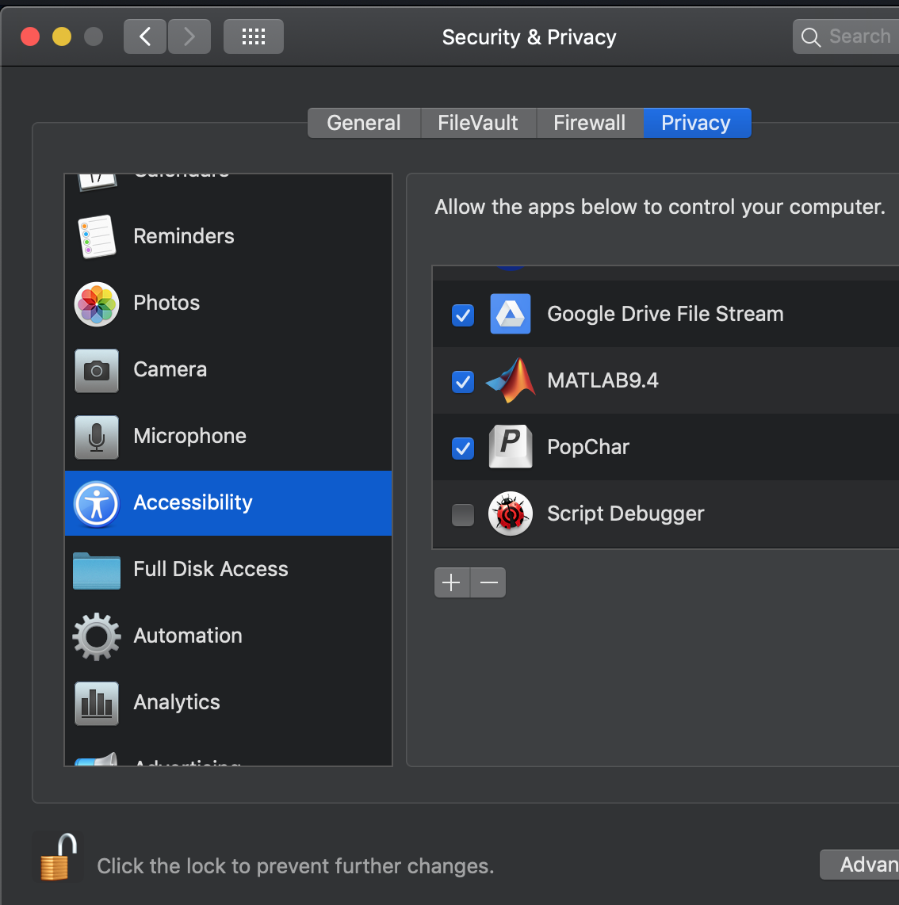 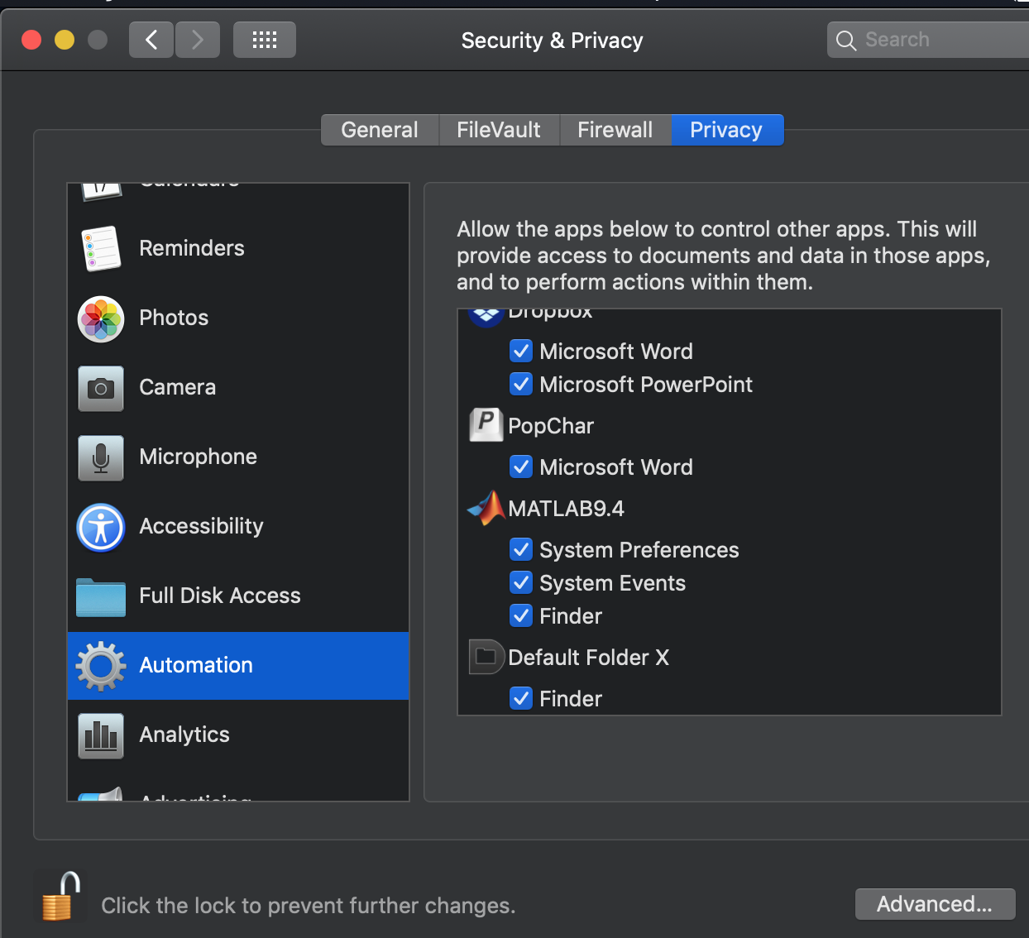  
   **Try it:** You can confirm that MATLAB has the needed permissions by typing AutoBrightness(0). If it has permission, it returns 0 or 1 (indicating whether autobrightness is off or on), but will return -99 if it lacks permission.
5. **✅** **macOS***:* **Install the Psychtoolbox kernel driver.** For explanation, type into MATLAB:  
    help PsychtoolboxKernelDriver  
   Currently I believe the Psychtoolbox Kernel Driver helps only if your video driver is from AMD (aka Radeon). The 15” MacBook Pro and the 27” iMac both have Radeon video drivers.   
   **Check status of PsychtoolboxKernelDriver:** You can check the kernel driver status at any time by typing into Terminal:  
    kextstatus -b PsychtoolboxKernelDriver  
   To test in MATLAB whether the PsychtoolboxKernelDriver is loaded, write this:   
    psychtoolboxKernelDriverLoaded=~system('kextstat -l -k | grep PsychtoolboxKernelDriver > /dev/null')  
   It returns 1 if loaded and 0 otherwise.  
   **CANNOT INSTALL UNDER CURRENT macOS, 10.14.5.** As of June, 2019, under macOS 10.14.5, we are currently unable to install the Psychtoolbox kernel driver. All the steps (including the disabling of SIP) seem to work without error, but the driver never loads. In several computers we installed the driver long ago, under earlier versions of macOS, and they continue to successfully use the driver under the new macOS 10.14.5. We just can’t newly install under 10.4.5. Stay tuned.   
   **Disable SIP**: The current macOS silently blocks driver installation. To overcome this, ​temporarily [disable the System Integrity Protection](https://www.macworld.co.uk/how-to/mac/how-turn-off-mac-os-x-system-integrity-protection-rootless-3638975/) (SIP, click the link) before installation. First, to reboot your macOS computer into the recovery partition,  
   select Apple Menu:Restart, and when you hear the boot chord press and hold Command-R. Then disable it by running Terminal with the command:  
    csrutil disable  
   Then reboot normally.   
   **Enable SIP**: You should eventually reenable SIP, once you’re sure the kernel driver is installed. To reenable SIP, reboot again into the recovery partition and type into Terminal:  
    csrutil enable  
   Then reboot normally.  
   **Remove old PsychtoolboxKernelDriver:** I’m told that it’s important to remove any failed installation first (e.g. failed because SIP was active). If there might be an old copy of the kernel driver, begin by deleting it, by running these two commands in Terminal:  
    sudo kextunload /System/Library/Extensions/PsychtoolboxKernelDriver.kext  
    sudo rm -R /System/Library/Extensions/PsychtoolboxKernelDriver.kext  
   **Install new PsychtoolboxKernelDriver:** Then install the kernel driver by pasting these two commands into Terminal:  
    cd /System/Library/Extensions/  
    sudo unzip /Applications/Psychtoolbox/PsychHardware/PsychtoolboxKernelDriver64Bit.kext.zip  
   Adjust the highlighted part of the address according to where you placed the Psychtoolbox. For example, in my lab, we use this location:  
    sudo unzip ~/Dropbox/PelliLabSoftware/Psychtoolbox/PsychHardware/PsychtoolboxKernelDriver64Bit.kext.zip

**Haven’t tried these:**sudo chmod -R 755 kextfile.kext  
sudo chown -R root:wheel kextfile.kext

Now remove the kext caches:

sudo rm -R Extensions.kextcache  
sudo rm -R Extensions.mkext

Several minutes after running those Terminal commands, the extension should load automatically. Rebooting will also load them. When first loading, the macOS may ask you to give permission, and then will allow you to approve system extensions signed by “Cambridge Research Systems Ltd”.   
**More elaborate kernel installation instructions:**  
<http://osxdaily.com/2012/01/12/how-to-manually-install-kernel-extensions-in-mac-os-x/>

1. Please run **InstallationCheck.m** to make sure that your computer is ready to run NoiseDiscrimination.m or CriticalSpacing.m. It quickly assesses all the issues checked **✅** above. I hope this will save us time, by helping us get each computer ready before we try to run NoiseDiscrimination or CriticalSpacing.

### C. Install CriticalSpacing

1. *Download* the CriticalSpacing software: <https://github.com/denispelli/CriticalSpacing/archive/master.zip>
2. *Unpack* the “zip” archive, producing a folder called CriticalSpacing.
3. *Allow remote typing.* A normally sighted observer must be many meters away from the screen, and thus will be unable to reach a laptop keyboard attached to the screen. The quickest way to overcome this is for the experimenter to type what the observer says. A more convenient solution is to get a wireless or long-cable keyboard.
4. *Measure distance.* The viewing distance will usually be more that 2 meters. You’ll need a tape measure, with centimeters, or a laser measure.
5. *Choose a font*. We recommend Pelli for threshold spacing in the fovea, and Sloan for everything else.
6. *Show the alphabet*. While running CriticalSpacing, once the testing has begun, you can press the shift key at any time to see a full-screen display of the alphabet of possible targets, in the target font. Before running the experiment, we recommend that you get a paper display of the alphabet by printing the appropriate PDF for your font. Look inside the the CriticalSpacing/pdf/ folder, e.g. Pelli.pdf and Sloan.pdf. Print the appropriate page and give it to your observer. The alphabet page shows the possible letters, e.g. DHKNORSVZ or 1234567889. Observers will find it helpful to consult this page while choosing an answer when they have little idea what letter the target(s) might be. And children may prefer to point at the target letters, one by one, on the alphabet page.
7. *Run a script.* To test an observer, double click runCriticalSpacing or your own modified script. They're easy to write. Say "Ok" if MATLAB offers to change the current folder. The program automatically saves your data to the CriticalSpacing/data/ folder. (If necessary, the folder will be created.) The test takes 10 min to test one observer (with 20 trials per threshold), measuring four thresholds. (You can increase o.trialsDesired in your script from 20 to 40 for a more precise threshold estimate.)
8. *Type “help CriticalSpacing”* in the MATLAB Command Window for documentation on use of CriticalSpacing.

### D. Install NoiseDiscrimination

1. Use GitHub to clone the NoiseDiscrimination software, making a local repository on your disk:   
   <https://github.com/denispelli/NoiseDiscrimination/>

My favorite GitHub client is Tower. It’s much more intuitive than the free clients that I tried. Using GitHub makes it easy to keep updating your copy from the master as new features are added and bugs are fixed.

1. *For long viewing distances: Allow remote typing.* A normally sighted observer must be many meters away from the screen, and thus will be unable to reach a laptop keyboard attached to the screen. The quickest way to overcome this is for the experimenter to type what the observer says. A more convenient solution is to get a wireless or long-cable keyboard.
2. *Install the Sloan and Pelli fonts.* Just double-click the Sloan.otf and Pelli-EyeChart_11hf.otf files inside the NoiseDiscrimination folder. For each, the Font Book app will ask if you want to install it. Say yes.
3. *Measure distance.* If the viewing distance is more that 2 meters you’ll need a tape measure, with centimeters, or a laser measure.
4. *Run a script.* To test an observer, double click runNoiseDiscrimination or your own modified script. They're easy to write. Say "Ok" if MATLAB offers to change the current folder. The program automatically saves your data to the NoiseDiscrimination/data/ folder. (If necessary, the folder will be created.) The test takes 10 min to test one observer (with 20 trials per threshold), measuring four thresholds. (You can increase o.trialsDesired in your script from 20 to 40 or more for a more precise threshold estimate.)
5. *Type “help NoiseDiscrimination”* in the MATLAB Command Window for documentation on use of NoiseDiscrimination.

### E. Optional: Install mQuestPlus

Some of our MATLAB scripts use the mQuestPlus toolbox to measure the psychometric function. Follow this link to get mQuestPlus:

<https://github.com/BrainardLab/mQUESTPlus>

Please put it in your Applications folder. Make sure the folder name is precisely "mQuestPlus". You might need to remove a trailing "-master".

### F. Optional: Install camera support

**✅** If your software will want to use your laptop’s built-in camera to photograph the observer’s eyes (as a cheap rough way to check fixation), then you must install the free MATLAB package that provides USB web cam support. Note that, though free, Mathworks demands an account name and email. If you don’t have one, they show you how to get one free. <https://www.mathworks.com/help/supportpkg/usbwebcams/ug/snapshot.html>

### G. Buy tools

1. A *meter stick* for short viewing distance; *Tape or laser measure* for long viewing distance. If the viewing distance exceeds a meter, a meter stick won’t be enough. It's important that you set viewing distance accurately, within five percent. You can measure it with a $10 tape measure marked in centimeters. A fancy $40 alternative is a Bosch laser measure, which gives you the answer in two clicks. The laser will work even with a mirror.  
   <http://www.amazon.com/gp/product/B0016A2UHO>  
   <http://www.amazon.com/gp/product/B00LGANH8K>  
   <https://www.boschtools.com/us/en/boschtools-ocs/laser-measuring-glm-15-0601072810--120449-p/>
2. An *eye patch.* Each person should have his or her own eye patch, to avoid transmitting germs. They come in various sizes. Choose one that comfortably fits your face. I suggest putting a piece of tape with your name on it, so everyone knows it’s yours.  
   <https://www.amazon.com/Black-Elastic-Eye-Patch-Single/dp/B00BCNKU2C>  
   <https://www.amazon.com/Flents-Eye-Patch-3-Pack/dp/B001THK0BM/ref=pd_bxgy_121_2>  
   <https://www.amazon.com/FCAROLYN-Pirate-Leakage-Smooth-Comfortable/dp/B01CWRSWBW/ref=pd_bxgy_121_3>  
   <https://www.amazon.com/Adult-Elastic-Patch-Black-Package/dp/B000B63RNA>
3. For long viewing distance: *A wireless or long-cable keyboard* is highly desirable because a normally sighted observer viewing foveally has excellent vision and must be many meters away from the screen, and thus will be unable to reach a built-in keyboard attached to the screen. If you must use the built-in keyboard, then have the experimenter type the observer's verbal answers. I like the Logitech K760 $86 solar-powered wireless keyboard, because its batteries never run out. It's no longer made, but still available on Amazon and eBay (below). To "pair" the Logitech keyboard with your computer's blue tooth, press the tiny button on the back of the keyboard.

Logitech Wireless Solar Keyboard K760 for Mac/iPad/iPhone

<http://www.amazon.com/gp/product/B007VL8Y2C>

1. For long viewing distance: *Mirror.* In a small room, you might need a mirror to achieve a long viewing distance. When CriticalSpacing or NoiseDiscrimination asks you about viewing distance, you can indicate that you're using a mirror by entering the viewing distance as a negative number. It will flip the display to be seen in a mirror. (You can also request this, in advance, by setting o.flipScreenHorizontally=1; in your run script.) I bought two acrylic front surface mirrors for this. 12x24 inches, $46 each from Inventables. Front surface mirrors preserve image quality, and acrylic is hard to break, making it safer than glass. I'm not yet sure how big a mirror one needs to accommodate observers of various heights, so I listed several of Amazon's offerings, ranging up to 24" by 48". The five-pack is a good deal, five 12"x24" mirrors for $67.

<http://www.amazon.com/Acrylic-Wall-Mirror-Size-24/dp/B001CWAOJW/ref=sr_1_19>

<http://www.amazon.com/Childrens-Factory-Look-At-Mirror/dp/B003BL7TMC/ref=sr_1_14>

<https://www.inventables.com/technologies/first-surface-mirror-coated-acrylic>

<http://www.amazon.com/12-24-Mirror-Acrylic-Plexiglass/dp/B00IVWQPUI/ref=sr_1_39>

<http://www.amazon.com/12-Acrylic-Mirror-Sheet-Pack/dp/B00JPJK3T0/ref=sr_1_13>

<http://www.amazon.com/Double-Infant-Mirror-surface-Approved/dp/B0041TABOG/ref=pd_sim_sbs_468_9>

### H. Acknowledgements

Thanks to Mario Kleiner, currently the main developer of Psychtoolbox, and Paul Fan, [paul.fan@nyu.edu](mailto:paul.fan@nyu.edu), who seems to always know how to get new software to work. Thanks to Hörmet Yiltiz for help getting CriticalSpacing to run under Windows.